中国古代圣贤孔子曾说：“因材施教“。在设计education单元的内容时，我们根据年龄将教育对象分成了四个模块。并设计了不同的教育形式，准备了不同的对应内容。

就像他说的，我们根据年龄不同，将受众分成了4个部分面对不同的人群，我们用不同的语气、不同的展现形式、不同的规模，向不同组的人传授不同的知识。

The ancient Chinese sage Confucius once said, "Teach students according to their aptitude" . Therefore, we divided our audience into four groups based on thier ages. Then we peovide diverse knowledge in different way according to their features.

小学

在中国，学生们在步入高中之前都没有具体的接受过专门的“生物课”，取而代之的，是涵盖物理化学生物的“科学课”。为了让低龄人群更早拥有独立的“生物”概念，我们ZJUT-China团队通过浙江工业大学生物工程学院与德清县秋山小学取得联系，为四年级的孩子们上一节生动形象的生物课。小学的孩子精力旺盛、好奇心重，因此我们选择了以PPT和表演结合的形式授课，并在建立了基础生物知识后，用制作安全的纸模的方式来让孩子们了解基础的微生物外观。

In China, students do not have a specific “biology class” until they enter high school, but rather a "science class" that covers physics, chemistry, and biology. (两种翻译你们看看，觉得哪个比较合适）

In China, instead of taking a specific “biology class”, students who at a young age usually have a "science class", which covers physics, chemistry and biology. （后面这句我改变了中文的意思，按照我的想法做了一些调整：Aiming to provide the younger group with an early and independent concept of “biology”，our team members decided to provide a vivid lesson to the children in primary school. So we contacted Qiushan Primary School in Deqing County through College of Bioengineering , Zhejiang University of Technology. In view of their lacking in biological knowlege, we decided to use a more concrete and visual way to help them with establishing basic biology conept, for example, slides and model-making.

9月28日下午2点，我们的团队成员们到达秋山小学。课堂的前半部分，我们向孩子们讲授了DNA以及基因变异的基础概念。我们的每一次提问都收获了孩子们热烈的回应，“为什么鸡妈妈生不出虎宝宝？”“为什么小朋友们和自己的爸爸妈妈长得像？”一个个问题，在刺激着孩子们的好奇心的同时，也帮助他们一步步树立着正确的生物观念。在孩子们运用自己刚学到的知识为“农民张叔叔”解决难题后，我们开始教授孩子们制作纸模。寨卡病毒因为结构简单、便于制作且没有尖锐的角，成为了我们的选择。制作模型的过程中，孩子们理解了微生物是什么，微生物的外观。希望今天的课可以成为一个契机，能够吸引孩子们在长大后继续喜爱生物、探索生物、为生物学的发展做出贡献。

At 2 pm on September 28th, our team members arrived at Qiushan Primary School. We taught the children about DNA and genetic variation. Then we used the questions we prepared in advanced to test their understanding about our lessens. And we are happy to see each question received positive response. After that, we started to make Zika models with them. We chose Zika because its model is simple and easy to make, and doesn't have sharp horns which is suitable for our young listeners. We hope that by making models, children can better understand what microbes are and our lesson can attract them to explore the mistry of biology and contribute to the development in biology in the future .

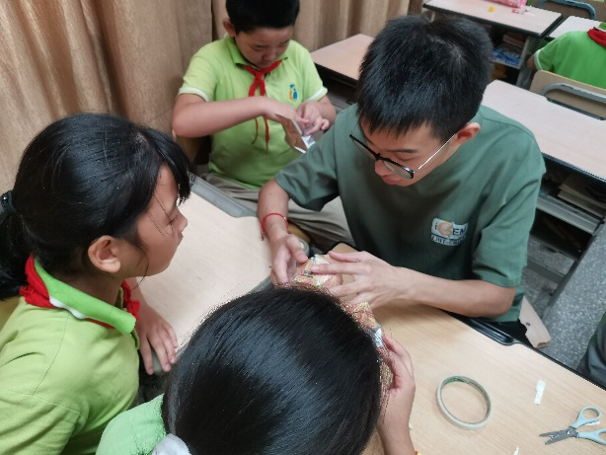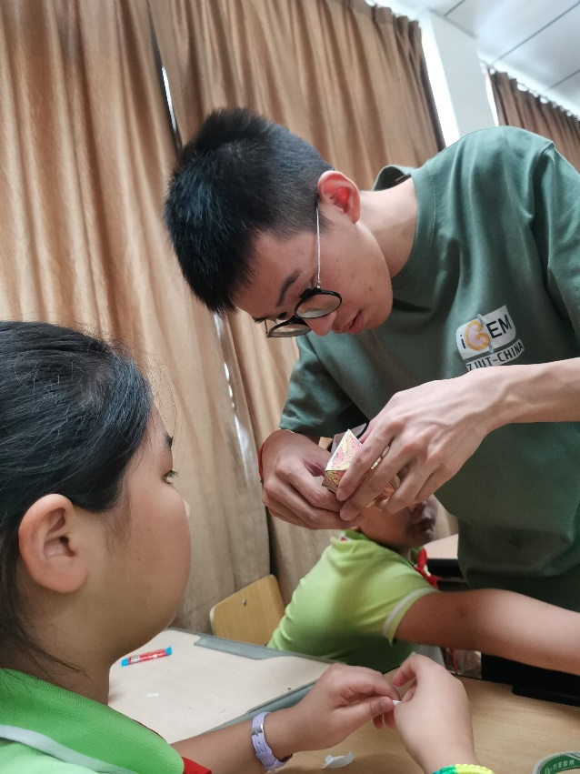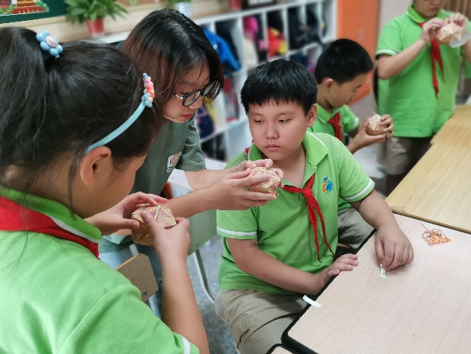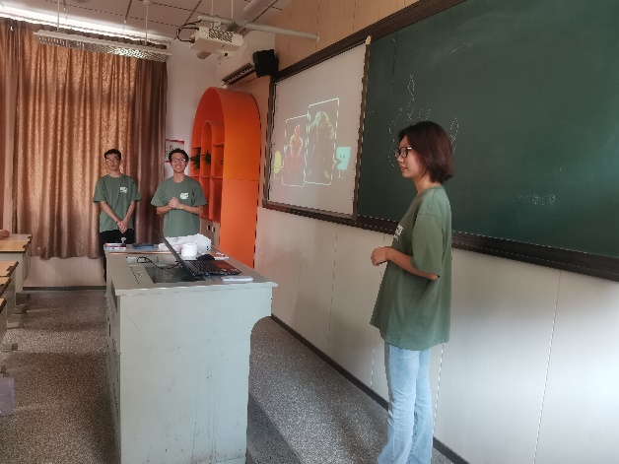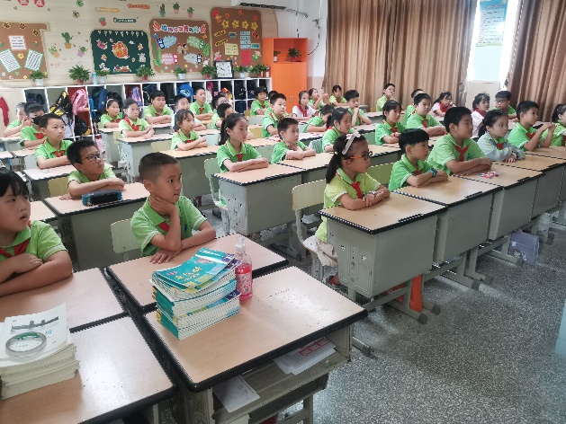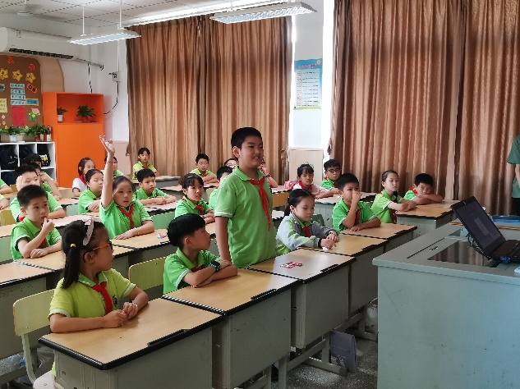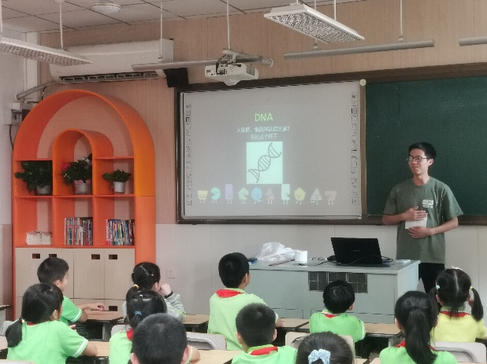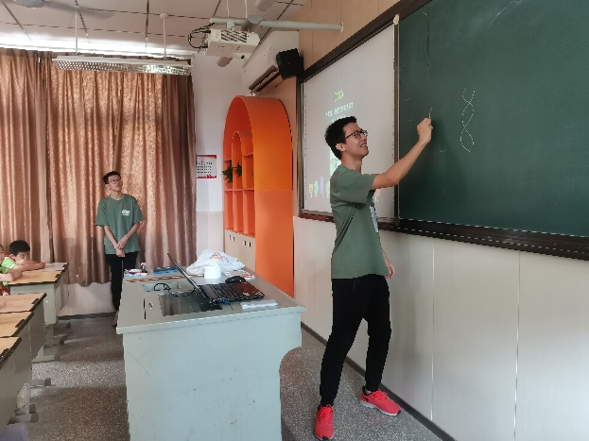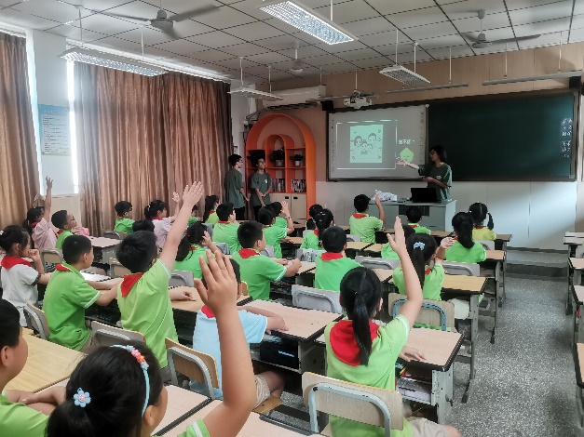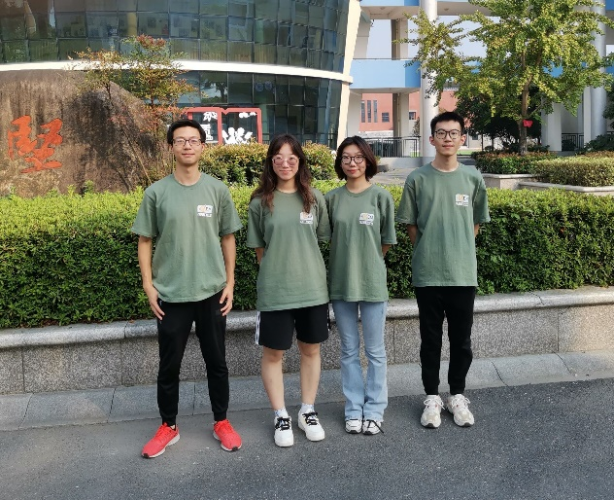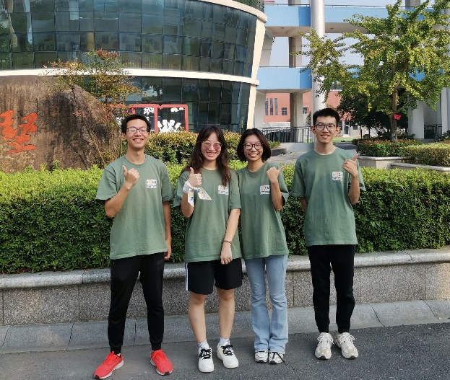

中学

中学生相比起小学生，已经拥有了基础的生物学知识，因此我们可以用更加专业的语言去向他们阐述我们的工作。8月29日，我们参与了由浙江工业大学生物工程学院主办的高中生暑期夏令营活动。我们用合适的语言向高中生们解释了我们项目的机理。然后，身为前辈的我们深知高中的生物和大学的生物是不同的，因此我们对两者间的差异作了阐述：与高中时期单纯的理论知识相比，我们在大学不仅需要学习比高中更加细致繁杂的知识，更需要掌握大量的实验技能，同时不同于高中固定的时间安排，大学生需要自主安排任务。经过我们的讲解，参会的高中生们表示受益匪浅，对我们的项目和高中大学间的差异皆有了深入了解。

Compared with primary school students, middle school students already have basic understanding of biology, so we can explain our work to them in a more professional way. On August 29th, we participated in the summer camp for senior high school students sponsored by College of Bioengineering , Zhejiang University of Technology. We explained the mechanics of our program to the high school students in an appropriate language. After the summer camp, those students benefited a lot and had a deep understanding of our program and the differences between high school and university.

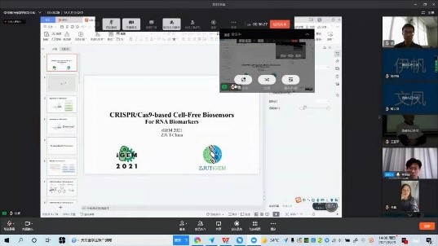

大学

对大学生的教育主要针对大一新生，他们刚刚接触大学生活，一场讲座可以帮助他们更快的适应大学生活和发现自己的兴趣所在。我们于5月、9月分别开展了学而论坛讲座和实验室开放日。

学而论坛：5月9日，我们团队受浙江工业大学学而论坛邀请，为大一新生作与iGEM赛事内容相关的讲座。作为iGEMer和senior student，我们与他们分享了参与比赛的经验，宣传了iGEM这一合成生物学领域的赛事。

Education for college students is mainly aimed at freshmen, who are new to college life, and a lecture can help them adapt to college life faster. We held the Study Forum and the Lab Open Day in May and September respectively.

Study Forum: On May 9th, our team was invited by Study Forum to give a lecture related to the content of iGEM to the freshmen. As iGEMers and senior students, we shared with them our experience of participating in the competition and promoted iGEM as the top event in synthetic biology.

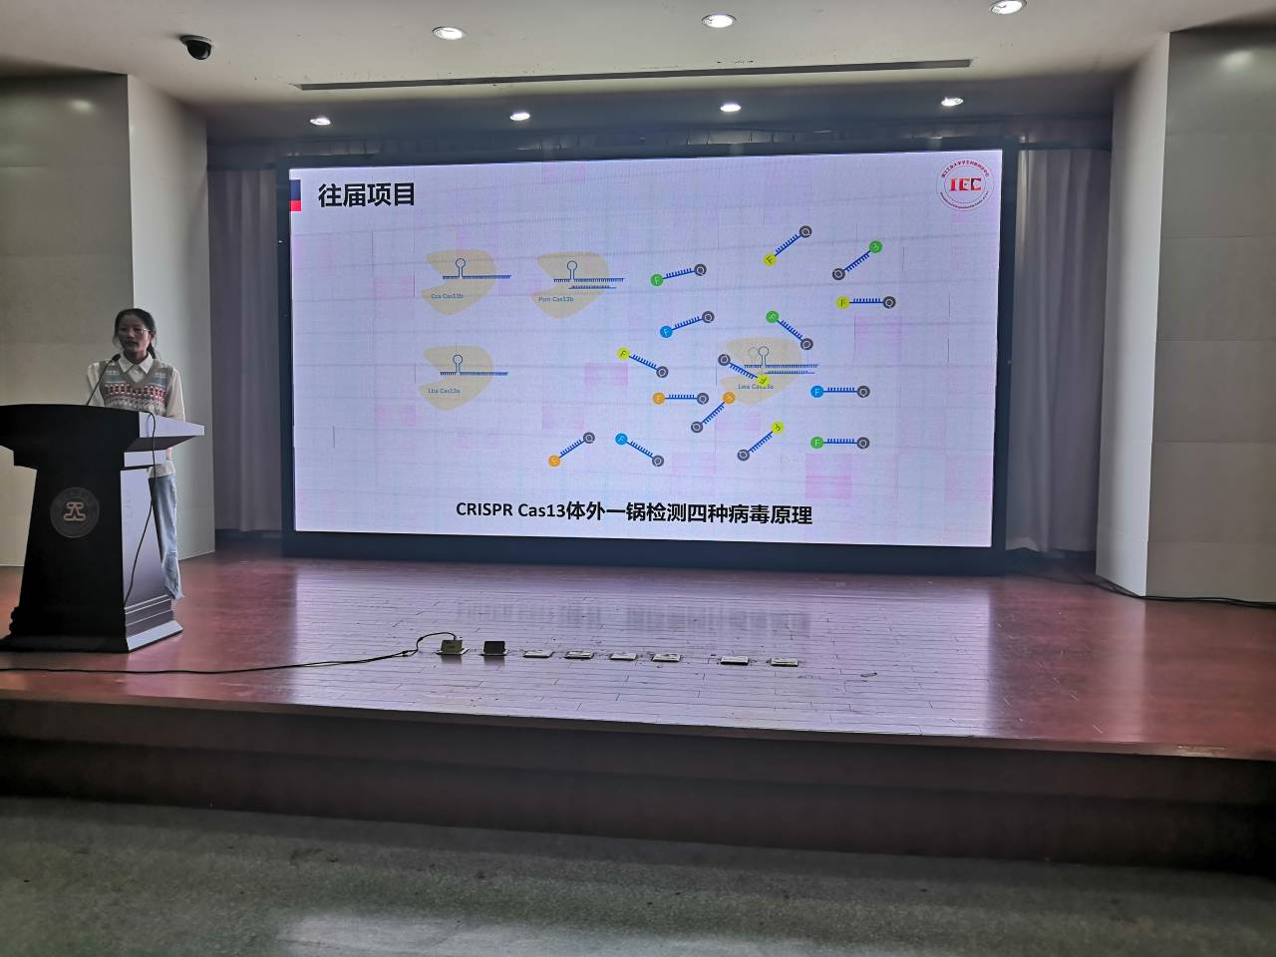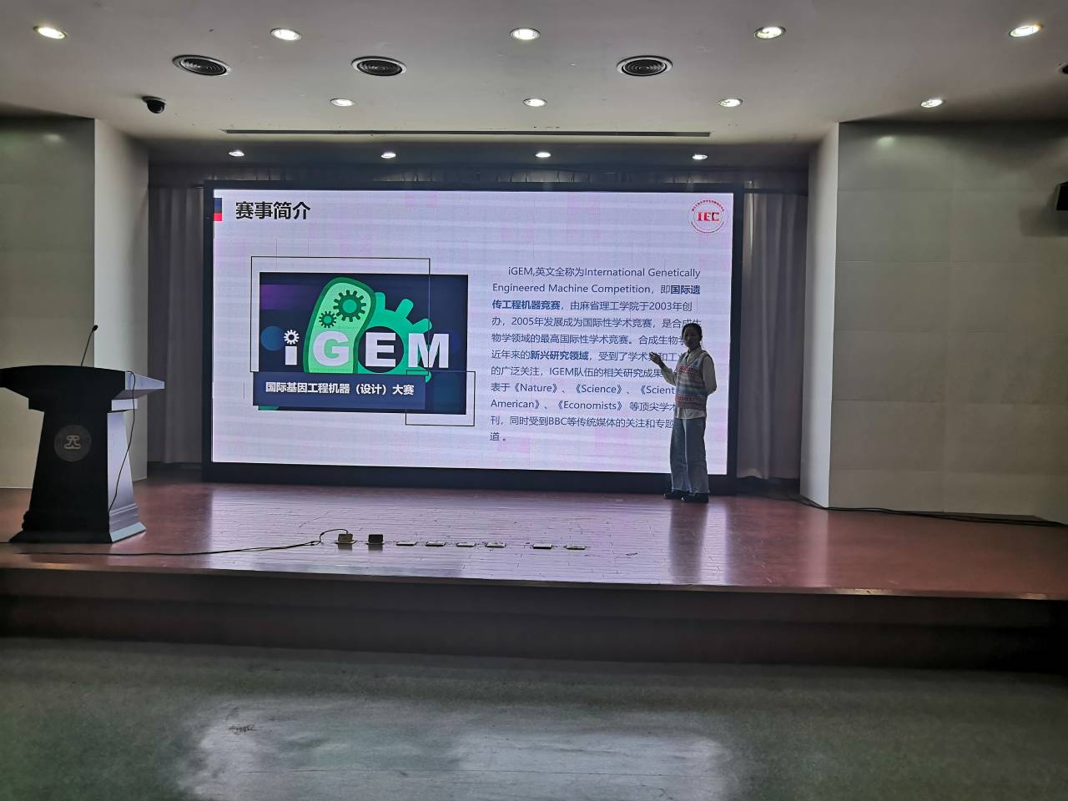

实验室开放日：

为了培养同学们的基础实验素养，进一步提升iGEM项目知名度, 我们于9月12日下午举办了一场面向2021级新生的实验室开放日活动。我们为该次实验开放日准备了四个项目，分别为仪器参观、点样与跑胶、配置培养基以及移液器的使用。这些是iGEMer日常最基础的实验操作。我们借助本次活动收集了同学们对iGEM的初印象和活动感想、提升了同学们的科学素养。

Lab Open Day:

In order to cultivate students' basic laboratory literacy and further promote iGEM, we held an lab open day for the freshmen in the afternoon of September 12. We prepared four separate programs: lab tour, agarose gel electrophoresis, use of pipettes and Culture media preparation. These are the most basic experimental operations that iGEMers do on a daily basis. Through this event, we collected students' first impressions of iGEM and their thoughts on the event, and improved their awareness of synthetic biology.

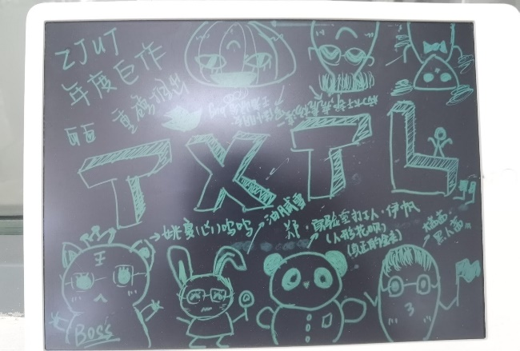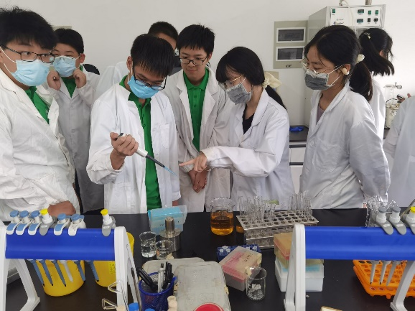

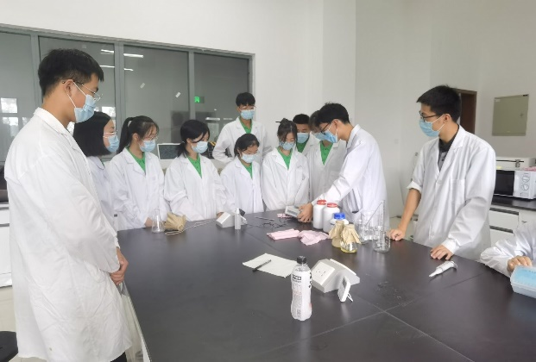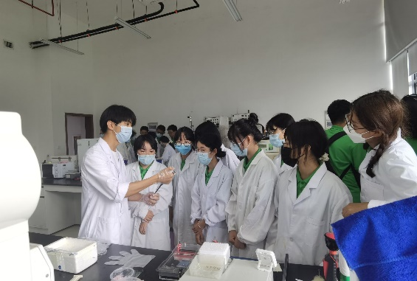

全年龄段：

微信公众号是一种用于进行一对多的媒体性行为活动，公众号的持有者可以发布一篇经过排版的图文给所有关注了公众号的用户。微信在中国的应用十分广泛，可以说是中国的instagram或facebook。因此，我们团队十分注重微信公众号的运营。除了日常的项目进度汇报，我们还专注于用公众号发布科普文章，内容与我们推进项目时用到的技术密切相关，包括但不限于无细胞系统、米氏方程等等。我们在公众号上累计发布推文16篇，累计关注人数达461人。

For all ages

WeChat (Chinese: 微信;) is a Chinese multi-purpose instant messaging, social media and mobile payment app which has been described as China's "app for everything" and a "super app" because of its wide range of functions. Therefore, we pays much attention to the management of the WeChat public accounts. In addition to our daily progress notes, we also focus on using our public accounts to publish scientific articles that are closely related to the technologies we use, including but not limited to cell-free systems, Michaelis-Menten equation, etc. We have published 16 tweets on our public website, with a total of 461 followers.

